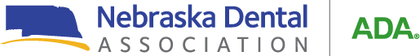

**Register –**

2025 West District Annual Meeting

Registration Form

# 9 AM –4PM – Friday, September 12, 2025

# Gering, NE.

* **Mail the registration form with a check/credit card to the Nebraska Dental Association, 7160 South 29th Street, Suite 1, Lincoln, NE. 68516.**
* **Fax or email the registration form with a credit card to 402-476-2641 or** [**jody@allophone.com**](mailto:jody@allophone.com)
* **Register onsite the morning of Friday, September 12, 2025. *We do encourage you to register BEFORE the meeting so that we can obtain accurate counts for food*.**

# Registration Fees – Registration fee includes continental breakfast and lunch.

* **NDA West District Member Dentist - $150 x = $**
* **Hygienist, Assistant, Staff, Spouse - $75 x = $**
* **Non-NDA West District Member Dentist - $200 x = $**
* **Total Submitted: $**
* **Credit Card # Exp. Date:**

Primary Registrant: Title: Address: City: State: Zip:

Phone: Email:

Name: Title: Address: City: State: Zip:

Phone: Email:

Name: Title: Address: City: State: Zip:

Phone: Email: