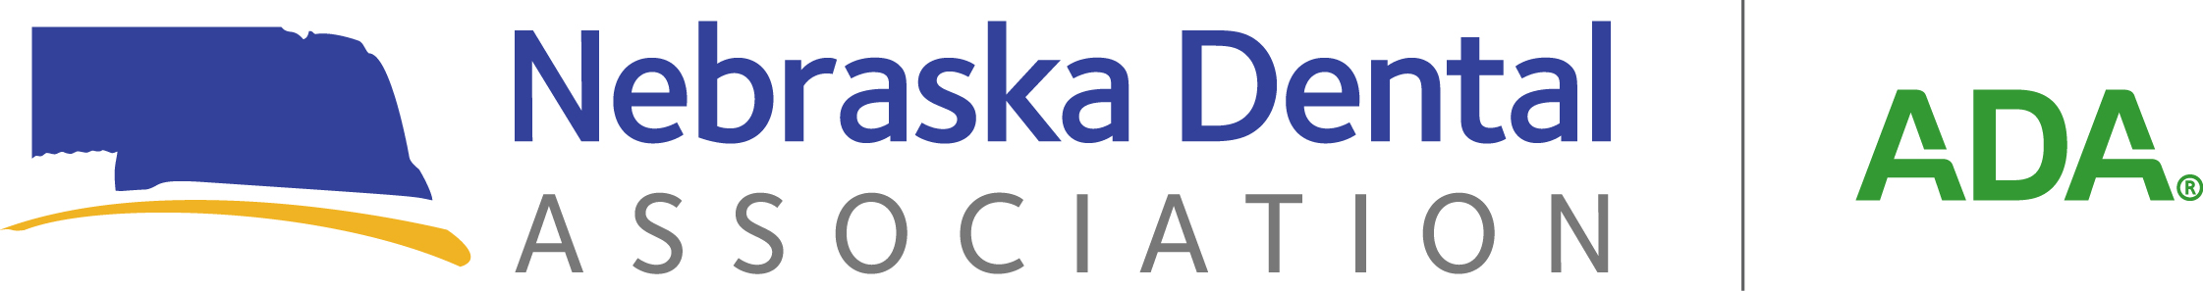

**Exhibitor Information - West District Dental Society**

**Friday, September 12, 2025**

**Gering Civic Center, Gering, Nebraska**

***Location:*** Gering Civic Center, 1050 M Street, Gering, Nebraska.

***Exhibit Times:*** All displays should be in place by 8:00 a.m. during breakfast/registration. Exhibit hours will be from 8:00 a.m. to 2:00 p.m. on Friday, September 12, 2025.

***Cost:*** **$100.00 per table** and includes 6 ft. table, 2 chairs, and Friday continental breakfast and lunch for **two** company representatives. **Exhibitor spaces need to be reserved by September 5, 2025.**

***Continental Breakfast & Lunch:*** The exhibitor registration fee includes a continental breakfast and lunch on Friday for two company representatives. Additional breakfast/lunch tickets can be purchased for $20.00 each. Breakfast will be available at 8:00 a.m. and lunch will be served at 12:00 p.m.

***Name Tags:*** Please provide the name of **each** person exhibiting with your company so that name badges can be prepared in advance of the meeting. **Name tags will be available on Friday morning at the Gering Civic Center.**

***Sponsorships:*** If you are interested in sponsoring the meeting, please contact West District President, Hayley Beaudette, [hayley.beaudette@gmail.com](mailto:hayley.beaudette@gmail.com), or Jody Cameron at 402-476-1704, or email [jody@nedental.org](mailto:jody@nedental.org). As always, your assistance in sponsoring our meeting is appreciated! Please mark sponsorships on the contract and pay the agreed upon amount to the West District Dental Society in care of the NDA office, 7160 South 29th Street, Suite 1, Lincoln, Nebraska, 68516.



**2025 WEST DISTRICT DENTAL SOCIETY**

**EXHIBITOR REGISTRATION FORM**

Please fill out the exhibitor registration and send it with payment to Jody Cameron, c/o Nebraska Dental Association, 7160 South 29th Street, Suite 1, Lincoln, NE. 68516, before **August 5, 2025**.

***Please make checks payable to the West District Dental Society***

Company Name ________________________________________________________________

Contact_______________________________________________________________________

Address_______________________________________________________________________

City____________________________________________State_______________ Zip________

Phone _______________________________________ Fax #____________________________

Email: ________________________________________________________________________

Names of representatives exhibiting:

1. ________________________________________________________________________
2. ________________________________________________________________________
3. ________________________________________________________________________
4. ________________________________________________________________________
5. ________________________________________________________________________
6. ________________________________________________________________________

_____ Yes, I want to exhibit at the West District Dental Society meeting on **Friday, September 12, 2025.** Enclosed is our $100 registration fee.

_____ Yes, I would like to purchase additional breakfast/lunch tickets at the cost of $20.00 per ticket. $20.00 x _____ tickets = $_______________.

_____ Yes, I would love to sponsor an event at the meeting. Please contact Jody Cameron at the NDA for further information. Sponsorships available: Breakfast sponsor (suggested $250); lunch sponsor (suggested $500); and speaker sponsor ($1,000). General sponsorships are also available. Please indicate which event you are sponsoring and for what amount: ______________________________________________________________________________

Total Enclosed: $_______________

***Credit card payments are available by calling Jody at the NDA office, 402-476-1704, or emailing Jody at*** [***jody@allophone.com***](mailto:jody@allophone.com)***.***