

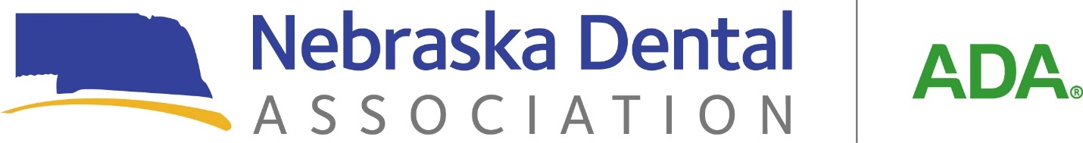

**WEST DISTRICT DENTAL SOCIETY ANNUAL MEETING**

**Friday, September 12, 2025**

**9 a.m. to 4 p.m.**

**Gering Civic Center, Gering, NE.**

The West District Dental Society Annual Meeting will be held on Friday, September 12, 2025, at the Gering Civic Center in Gering, Nebraska. Two separate CE tracks will run from 9 a.m. to noon, and 1 p.m. to 4 p.m. The West District members will meet for their business meeting at noon during lunch hour. Continental breakfast and lunch will be included.

**Session 1 - Full Arch Implant Surgery and 3D Printing: A Complete Digital Workflow**

**Speakers –**

**Dr. Tucker Rudisill Dr. Igor Borisovc**

Dr. Tucker Rudisill is a native of Hot Springs, Arkansas, and a graduate of LSU School of Dentistry, Class of 2021. Following dental school, he completed a one-year internship in Oral and Maxillofacial Surgery at LSU Health New Orleans, where he deepened his surgical skill set and clinical judgment. He completed two years of postdoctoral training in Comprehensive Oral Implantology through Jacksonville University at Implant Pathway in Phoenix, Arizona. His work is focused on full arch implant dentistry, with a strong interest in surgical efficiency, restorative workflow, and long-term case success. Dr. Rudisill is committed to delivering high-quality care through thoughtful treatment planning and technical precision. He takes pride in being part of a team that helps restore function, confidence, and quality of life for patients through advanced implant solutions.

Dr. Igor Borisov was born in Kharkiv, Ukraine, and spent his formative years in Baltimore, Maryland before pursuing his passion for dentistry at Midwestern University in Arizona. With a focus on digital approaches to implant surgery, Dr. Borisov utilizes cutting-edge technology to provide his patients with the most accurate and effective treatments available. He is committed to staying up to date with the latest advances in his field by attending and teaching continuing education courses and remaining an active member of the dental community. Dr. Borisov provides his patients with comfortable and positive dental experience, and he believes that technology plays a vital role in achieving this goal. His emphasis on digital workflows and 3D printing allows for precise, prosthetically driven planning and placement of dental implants, resulting in better outcomes for his patients.

**Course description -** Lecture-based course designed to introduce general dentists to the latest advancements in the digital workflow for full-arch implant rehabilitation. Participants will gain a comprehensive understanding of treatment planning, prosthetically driven planning, implant placement protocols, and prosthetic/guide fabrication using 3D printing. Emphasis is placed on integrating CBCT, intraoral scanning, and digital workflows to improve surgical accuracy, streamline the restorative process, and enhance patient outcomes in All-on-X style cases. This course is ideal for clinicians looking to elevate their full-arch offerings through digital innovation.

**SESSION 2 - The 8 Steps of Highly Effective Hygienists**

**Speaker –**

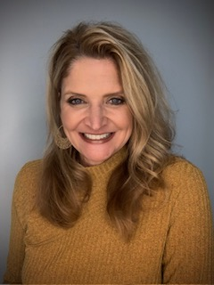

**Kendra Fox, BSDH**

Kendra Haynes Fox B.S. RDH graduated from UNMC College of Dentistry with her bachelor's degree in dental hygiene in 1991. She is celebrating 34 years as a hygienist this year with over 20 years of experience in the treatment and maintenance of patients in a periodontal office and fourteen years working in cosmetic and general dentistry. She also has experience as a clinical instructor at both Iowa Western Community College and the UNMC College of Dentistry Hygiene program in Lincoln, NE. Kendra’s passion for her profession stems from her firsthand knowledge of the devastating effects of periodontal disease on her patients. She believes preventive care and educating her patients is the key to overall optimal health. She has continued her education by becoming certified in Diode Laser applications in June 2022. Her office is the first in Nebraska to become a Guided Biofilm Therapy certified practice in February 2023 and currently the only certified office in Omaha, Nebraska. Kendra has been an SDA Guided Biofilm Therapy trainer for EMS since February of 2023.

Kendra’s focus is on biofilm disruption and its role in the treatment and prevention of periodontal disease and its effect on systemic health.

Kendra’s professional experience includes Past President of the Nebraska Dental Hygienists’ Association among many other NDHA positions. She has received awards such as Nebraska Dental Hygienist of the Year and Omaha Dental Hygienist of the Year. Kendra has participated in advisory panels for the 3M Corporation and the accreditation process of IWCC Dental Hygiene program.

**Course Objectives**:

* Evaluate the principles of traditional prophylaxis vs Guided Biofilm Therapy.
* Understand the oral/systemic link and how guided biofilm therapy is relative.
* Understand the difference between Airflow and Perioflow, Piezon vs Piezo and Magnetorestrictive.
* Recognize and implement the 8 step GBT protocol.

**The Future of Instrument Processing**

**&**

**OSHA For Your Office**

**Speaker –**

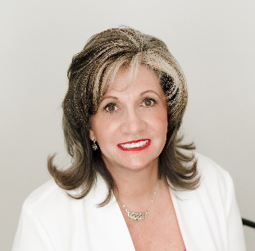

**Ronda Anderson with Hu Friedy**

Ronda Anderson has been in the Dental Industry for over 30 years. During her time as a distributor representative, she realized the need for education in her offices. They needed help with resourcing information on the latest in Government Compliance and Infection Control. So, she became a trainer in OSHA and Infection Control to help her customers learn about proper guidelines and protocols. This became a passion that has now culminated with her current employment at Hu Friedy Group where she consults with dental offices every day to help them become more efficient, compliant, and safe.

**Course Descriptions –**

**The Future of Instrument Processing**: After years of industry slumber, the dental sterilization sector is experiencing a seismic shift. Prepare to expand your knowledge beyond current practices to the evolving sector of Instrument Processing.

**OSHA for Your Office:** Gain a thorough understanding of the essential safety protocols required by the Occupational Safety and Health Administration (OSHA) for maintaining a secure workplace environment.