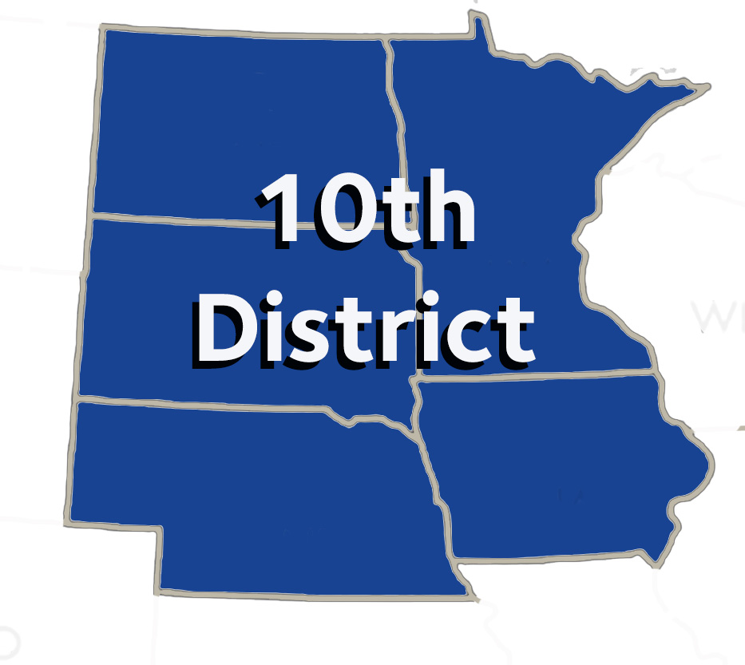

**MINUTES OF THE 10th District Caucus**

**Saturday, October 19, 2024**

Hilton New Orleans – Riverside

Those present were delegates and alternates: Drs. Chris Bogue, Ryan Hajek, Shawn Hedlund, Brian Kim, Sara Stuefen, Clark Stanford, Kevin Baker, 10th District Trustee Scott Morrison, Tom Alexander, Deb West, Emily Willett, Jessica Meeske, Alejandro Aguirre, Amber Cziok, Seth Huiras, Stephen McDonnell, James Nickman, John Noack, Rosalie Perpich, Loren Taple, Scott Wagnild, Geetha Damodaran, Douglas Erickson, Zachary Hazelton, Tim Holland, Walter Samuel, Brad Anderson, Otto Dohm, Peter Mecham, Michael Frankman, Jay Crossland, Jonathan Reth. Executive Directors: David O'Doherty, Laurie Traetow, Paul Knecht, William Sherwin. Constituent Staff: Jody Cameron. Via Zoom: Carmelo Cinqueonce.

The 10th District caucus was called to order at 7:30 a.m. by caucus Chair, Dr. Deb West of Nebraska. Dr. West declared a quorum present. Dr. West asked attendees to introduce themselves and include any ADA Councils or Committees they are on.

Motion to approve the Agenda was seconded. Motion carried.

Motion to approve the minutes of October 7, 2023, caucus meeting. Motion carried.

Dr. Morrison asked the Delegation to stay after the House regarding Strategic Forecasting.

Dr. West asked if there was any follow-up on the DICOM standard. Dr. Morrison directed the Delegation to Krishna Aravamudhan’s email posted on the NDA website.

Drs. West and Morrison asked the Delegation to pose possible questions to the candidates:

At 8:00 a.m., Dr. Ron Lemmo, current SFC Chair, addressed the Caucus regarding Strategic Forecasting. The SFC has elevated the voice of the HOD more than he thought it would. Also, collaboration has been effective. Dr. Lemmo opened the floor for questions from the Delegation.

Dr. Michael Frankman presented resolutions from Budget, Business, Membership and Administrative Matters: 202-205 are SFC related; 203 related to high-level percentage goals; 205, 206, Reports 2, 5, 7 & 8; 207, 208, 209 & 210.

Dr. Alejandro Aguirre and Dr. Hal Fair, ADPAC Chair, spoke briefly on ADPAC and the importance of taking ADPAC to the grassroots level. ADPAC will present a short video at the HOD.

Dr. Sara Stuefen presented resolutions from Dental Benefits, Practice & Matters: 301, 302, 303, 303B, 304, 305, 306 (MLR), 307, 308, 308B, 308BS-1, 309, 310, 311, 312, 313, 314, 315, 316, 317, 318, 319, 320, 321, 322 & 323.

Dr. Rose Perpich presented resolutions from Dental Education, Science & Related Matters: 401, 402, 403, 404, 404B, 405, 406, Report 4, 407, Report 6, 408, 409, 410 & 411. Dr. Meeske presented a substitution for Resolution 404, requiring Board of Dentistry members who are also examiners, disclose to potential for a conflict of interest when selecting a licensing exam. Motion to present the substitution at the Reference Hearing. Motion carried. Dr. Meeske will present at the Reference Committee.

1. Michelle Reeder from ADA presented information on the Pilot Program and Membership Model. Stephanie Moritz, new experiences such as Elevate leadership. New locations for CE. Robert Quashi, COO, generate more non dues revenue. Ray Cohlmia, ADA ED, value propositions for members. Engagement on an individual basis.

Dr. Scott Wagnild presented resolutions from Legislative, Health Governance & Related Matters: 501, 502, 503, 504, 505, 506, 507, 508, 509, 510, 511, 512, 513, 514, 514B, 515, 515B, 516, 517, 518, 519, 520 & 521.

* 1. Email candidate questions to Dr. West or David O’Doherty. Questions will be emailed out and voted on by the Delegation.

Mr. O’Doherty briefly outlined the 10th District Functions during the ADA House of Delegates.

Dr. Scott Morrison gave closing remarks.

At 12:21p.m. there being no further business, a motion for the caucus to recess until Monday, October 21, 2024, at 7:30 a.m., was seconded. Motion carried.

Respectfully Submitted  
David J. O’Doherty  
Secretary to the Caucus