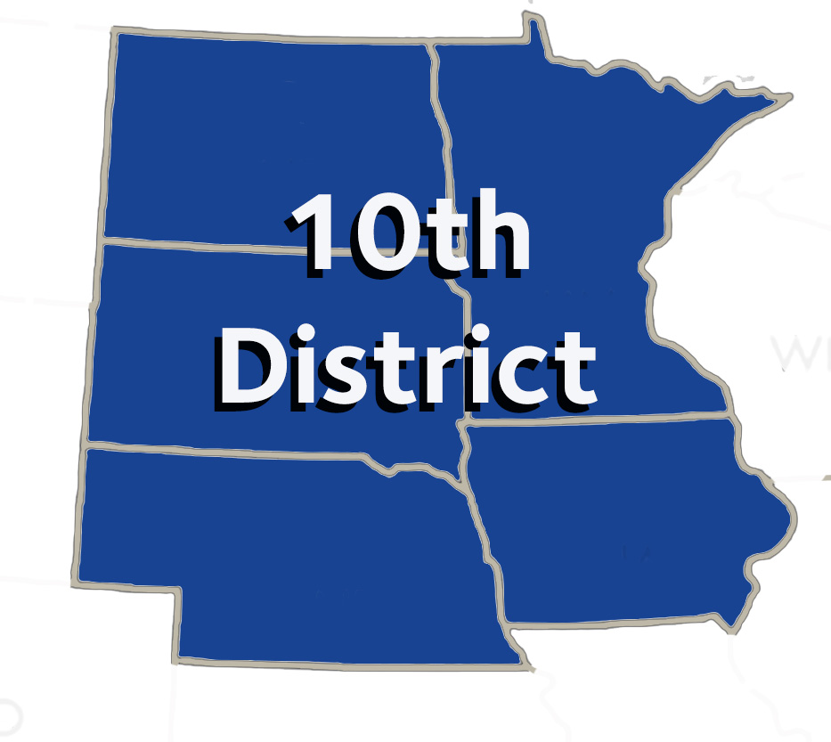

**MINUTES OF THE 10th District Caucus**

**Monday, October 21, 2024**

Hilton New Orleans – Riverside

Along with Scott Morrison, those present were delegates and alternates: Drs. Chris Bogue, Ryan Hajek, Shawn Hedlund, Brian Kim, Sara Stuefen, Clark Stanford, Kevin Baker, Scott Morrison, Tom , Alexander, Deb West, Emily Willett, Jessica Meeske, Liz Papineau, Alejandro Aguirre, Amber Cziok, Seth Huiras, Stephen McDonnell, James Nickman, John Noack, Rosalie Perpich, Loren Taple, Scott Wagnild, Geetha Damodaran, Douglas Erickson, Zachary Hazelton, Tim Holland, Walter Samuel, Brad Anderson, Otto Dohm, Peter Mecham, Michael Frankman, Jay Crossland, Jonathan Reth. Executive Directors: David O'Doherty, Laurie Trassetow, Paul Knecht, William Sherwin. Constituent Staff: Jody Cameron. Via Zoom: Carmelo Cinqueonce.

The 10th District caucus was called to order at 7:32 a.m. by caucus Chair, Dr. Deb West of Nebraska. Dr. West declared a quorum present. Dr. Papineau from Tyler Genis from ASDA District 8 (Iowa) have joined the caucus today.

Motion to approve the Agenda. Motion carried.

Motion to approve the minutes of the October 19, 2024 caucus meeting. Motion carried.

Dr. Morrison expressed his appreciation for everyone attending the Parade and Social at Oceana last night. A good time was had by all. Listen today during the caucus and don’t talk over anyone so we can do our work tomorrow at the House. Dr. West assigned Candidate questions to the Delegation.

Dr. Sara Stuefen presented resolutions from Dental Benefits, Practice & Matters: 301, 302, 303, 303B, 304, 305, 306 (MLR), 307, 308, 308B, 308BS-1, 309, 310, 311, 312, 313, 314, 315, 316, 317, 318, 319, 320, 321, 322 & 323.

At 8:27, the delegation heard from Treasurer candidate, Dr. Peter Shatz

Dr. West announced that North Dakota would host the caucus meeting in Washington D.C. in 2025. Dr. Brad Anderson will serve as the caucus chair, Dr. Michael Frankman to serve as vice chair and Mr. Will Sherwin was elected by consent.

Dr. Stuefen discussed scheduling of 2025 10th District Caucus Meeting, pre-caucus meeting second week in September after the second set of Resolutions are available. Dr. Franken suggested a later time of day. Mr. Sherwin will send out a Doodle poll to the Delegation to set a later time of date for the pre-caucus.

At 8:45, the delegation heard from President candidate, Maria C. Maranga

At 9:02 the delegation heard from President candidate, Dr. Richard Rosato

At 9:17 the delegation heard from Treasurer candidate, Dr. Howard M. Zolot

At 9:43 the delegation heard from President candidate, Dr. Rudolph T. Liddel

Dr. Michael Frankman presented resolutions from Business, Membership and Administrative Matters: 202-205 are SFC related; 203 related to high-level percentage goals; 205, 206, Reports 2, 5, 7 & 8; 207, 208, 209 & 210.

Dr. Rose Perpich presented resolutions from Dental Education, Science & Related Matters: 401, 402, 403, 404, 404B, 405, 406, Report 4, 407, Report 6, 408, 409, 410 & 411. Dr. Meeske reported that the RC did not do anything with her substitution for Resolution 404, requiring Board of Dentistry members who are also examiners, disclose to potential for a conflict of interest when selecting a licensing exam. Kecia Leary, CERP chair, addressed the Caucus regarding CERP recognition and Resolution 410, dropping criteria from over 105 to 17. Moving to an online process.

At 12:05 the delegation heard from 2nd Vice President candidate, Dr. Viren Jhaveri

At 12:25 the delegation heard from Treasurer candidate, Dr. David Manzanares

At 12:35 the delegation heard from President candidate, Dr Tamara Berg

At 12:47 the delegation heard from President candidate, Dr. Michael D. Medovic

At 1:10 the delegation heard from Treasurer candidate, Dr. Cody Graves

Dr. Scott Wagnild presented resolutions from Legislative, Health Governance & Related Matters: 501, 502, 503, 504, 505, 506, 507, 508, 509, 510, 511, 512, 513, 514, 514B, 515, 515B, 516, 517, 518, 519, 520 & 521.

At 1:54 the delegation heard from President candidate, Dr. Chad R. Leighty

No resolutions were identified requiring statements from the 10th District Delegation.

Dr. West reminded the Delegation of the timing for voting on Tuesday, doors open at 6:30 a.m.

Dr. Scott Morrison provided closing remarks.

There being no further business, a motion was made and seconded that the caucus adjourn. Motion carried.

Respectfully Submitted  
David J. O’Doherty  
Secretary to the Caucus