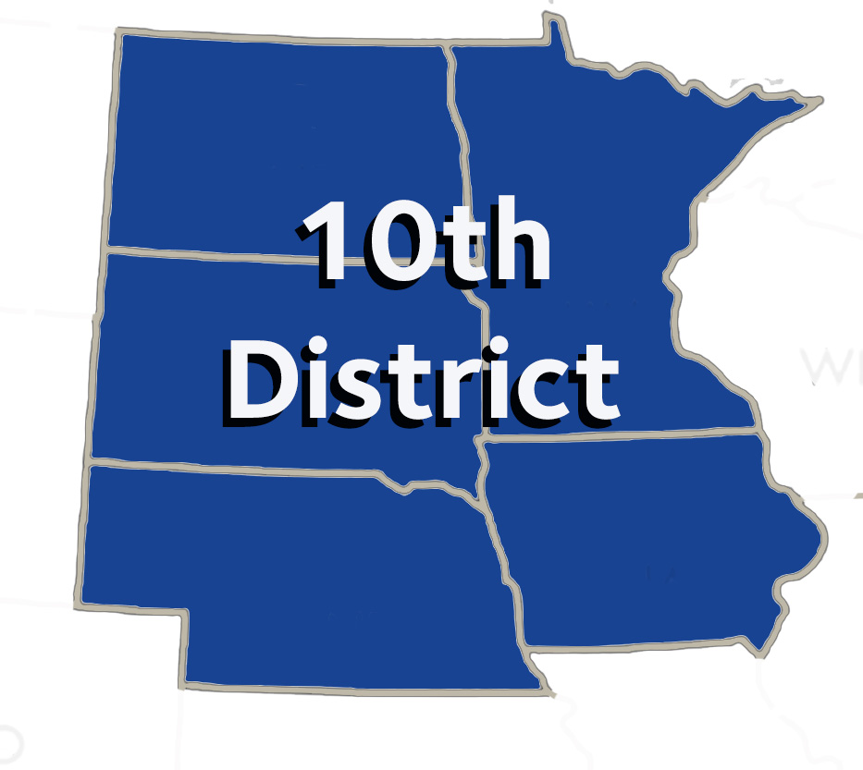

AGENDA

10th District Caucus

**Saturday, October 19, 202**

Hilton New Orleans – Riverside -   
Room Name: Jefferson Ballroom – 3rd Floor

7:30 AM (breakfast starts at 7:00 AM)

Dr. Scott Morrison, Trustee Dr. Brad Anderson, Vice Chair

Dr. Deb West, Chair Mr. David O’Doherty, Secretary

1. Call to Order –Establish Quorum – Dr. Deb West
2. Introduction of Delegates, Alternates, and Guests
3. Approval of Agenda
4. Approval of Minutes from October 9, 2023 Caucus Meeting
5. Announcements & Updates – Dr. Scott Morrison, 10th District Trustee ADA
   1. 6. Dr. Lemmo – Strategic Forecasting
   2. 7. Review of 2024 House of Delegates Resolutions

A. Budget, Business, Membership and Administrative Matters – Dr. Michael Frankman

B. Dental Benefits, Practice & Matters – Dr. Sara Stuefen

C. Dental Education, Science & Related Matters – Dr. Rose Perpich

D. Legislative, Health Governance & Related Matters – Dr. Scott Wagnild

8. Discussion of New or Additional Resolutions – Dr. Scott Morrison

9. South Dakota Resolution: DICOM Standard

10. Determine and assign questions for ADA Second Vice President and President-Elect candidates.

11. Tenth District Functions in New Orleans – Mr. David O’Doherty

12. Announcements/Closing Remarks – Dr. Scott Morrison

13. 10th District to Remain after the 1st HOD for Strategic Forecasting Summit.

Adjournment