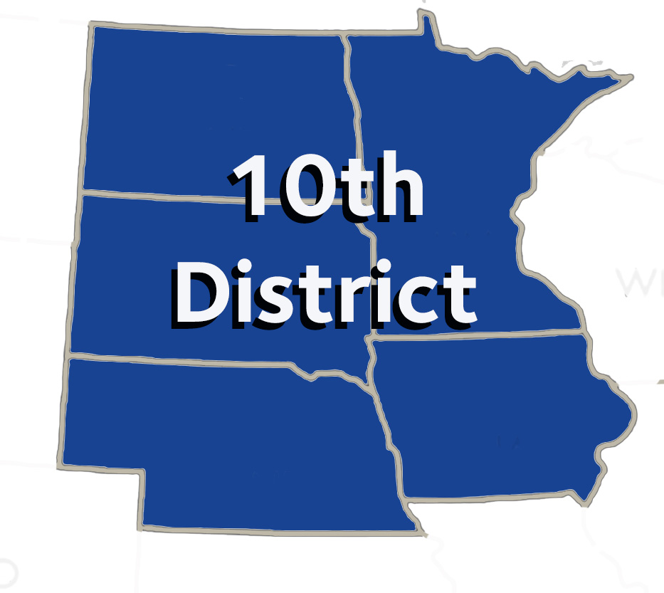

AGENDA

10th District Caucus

**Monday, October 21, 2024**

Hilton New Orleans – Riverside

Room Name: Churchill C1 – 2nd Floor

7:30 AM (breakfast starts at 7:00 AM)

Dr. Scott Morrison, Trustee Dr. Brad Anderson, Vice Chair

Dr. Deb West, Chair Mr. David O’Doherty, Secretary

1. Call to Order –Establish Quorum – Dr. Deb West
2. Additional Introductions
3. Approval of Agenda
4. Approval of Minutes from October 19, 2024 Caucus Meeting
5. Announcements & Updates – Dr. Scott Morrison, 10th District Trustee ADA
6. Candidates for ADA Offices will speak to the caucus during the course of business.
7. Reference Committee Reports:

A. Budget, Business, Membership and Administrative Matters – Dr. Michael Frankman

B. Dental Benefits, Practice & Matters – Dr. Sara Stuefen

C. Dental Education, Science & Related Matters – Dr. Rose Perpich

D. Legislative, Health Governance & Related Matters – Dr. Scott Wagnild

1. Identify resolutions requiring statements from the 10th District Delegation.
2. Scheduling of 2025 10th District Caucus Meeting
   1. Pre-caucus meeting?
3. Election of 10th District Caucus Officers (Chair, Vice-Chair, & Secretary)
4. Other Business
5. Announcements/Closing Remarks – Dr. Scott Morrison
6. Adjournment