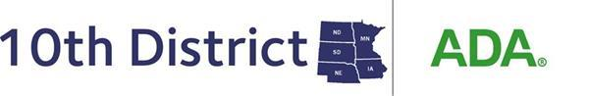
2024 Reference Committee A
Business, Membership and Administrative Matters
Resolution #________
Pros | Cons

